

MECH 415

Advanced Programming

A report submitted in partial fulfillments

of the requirements of MECH 415

Written by:

Hugo Provencher (40012598)

Hamza Briak (27480849)

Marc Enriel Quilatan (27775628)

Due

December 20, 2018

**INTRODUCTION**

The programming project that was done in this class is a small hovercraft simulation. The team decided to have a little more fun with the project and add some more gaming aspects towards it. The player has complete control of the hovercraft and must shoot the targets

**PROJECT**

As mention in the intro the project consists of a hovercraft that is controllable by the user. The goal of the simulation is to shoot rockets from the hovercraft to the target projected from our program. Equations use for the hovercraft are the following:

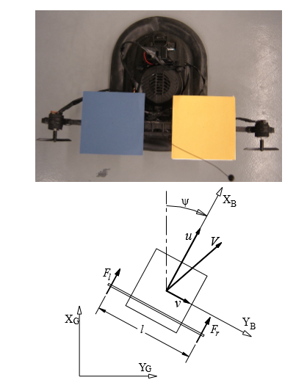

**Fig.1 Free Body Diagram for Simulation ( Given by Professor Gordon )**

$$dx=u$$

$$du=\frac{F_{l}+F_{r}-c_{1}u}{M}+v*r$$

$$dy=v$$

$$dv=-\frac{c_{2}*v}{M}-u*r$$

$$dψ=r$$

$$dr=\frac{0.5*L\&\left(F_{r}-F_{l}\right)-c_{3}*r}{J}$$

$${dx}_{c}=\cos\left(ψ\right)u-\sin\left(ψ\right)v$$

$$dy_{c}=\sin\left(ψ\right)u+\cos\left(ψ\right)v$$

**DIFFERENT FEATURES:**

* A “Kill counter” that counts how many targets were hit.
* Random messages that shows at 5,10,15 “kills”
* A mini hovercraft that follows the main hovercraft throughout the program
* An arrow that (really clunkily) shows you where the target is
* Top view + First person view. First person also has a crosshair to help the user to aim better.

**CONTROLS**

Left/Right Arrow Keys : Controls Left and Right Thrusters of the Hovercraft

Up Arrow: Switches between First Person and Third Person View

Down Arrow Key: Resets the hovercraft to its original position

Z/X : Reverse Thrusters

**CONCLUSION**

The project shows the introduction of simulations. All though fun, there is many aspects that can be improved within the project (borders, different levels, etc.). This was perfect to give us a taste of programming in a group while implementing different skills and techniques that was thought throughout the semester.